2019 Terrestrial Ecology Science Team Meeting Summary
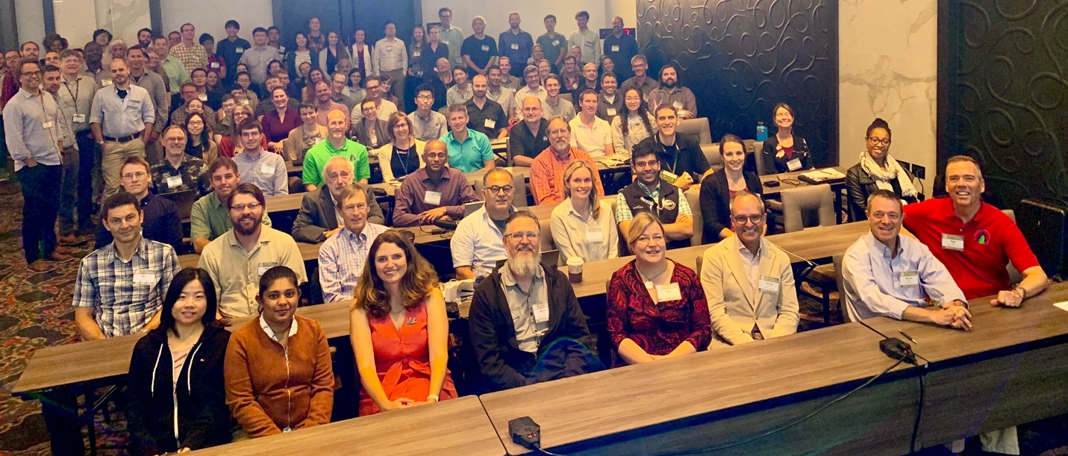
The 2019 Terrestrial Ecology (TE) Science Team Meeting was held in College Park, MD from September 23rd -25th 2019. This was the first full meeting of the Terrestrial Ecology Science Team since 2013. There were over 170 attendees (including 24 students and 10 postdocs) from a variety of organizations including NASA, other US federal agencies, and universities, among others. The goal was to (1) collectively assess the state of NASA Terrestrial Ecology science and (2) inform the TE community of new and emerging capabilities and assets. This was done via a series of plenary talks, posters sessions, and lively breakout discussions. The meeting highlighted research funded by the Terrestrial Ecology Program including Carbon Cycle Science (CCS) and Interdisciplinary Science (IDS) as well as the New Investigator Program (NIP) and Future Investigators in NASA Earth and Space Science and Technology (FINESST) programs. The Arctic and Boreal Vulnerability Experiment (ABoVE) and Carbon Monitoring Systems (CMS) programs were also discussed, but they were not the primary focus of this meeting because these programs have their own annual science team meetings. The more “senior” members of our community explained to the younger cohort of TE scientists that a multi-decadal, career-long commitment was required to succeed in realizing a spaceborne capability for the remote sensing of vegetation structure through lidar (GEDI) and radar (NISAR) and vegetation function through hyperspectral remote sensing (SBG).
Science results from TE funded research were discussed via oral presentations and during the poster sessions. In addition to PI science talks, 17 students gave outstanding speed talks and poster presentations on their TE funded projects. Three of these students received the first TE Outstanding Student Poster Award for their presentations:
Jiaying He, “Modeling cloud-to-ground lightning distribution in Alaskan tundra integrating Weather Research and Forecast (WRF) model and machine learning algorithm” (https://cce.nasa.gov/files/te2019_ab_presentations/TE2019_Poster_He_19_64.pdf)
Elizabeth Webb, “Vegetation Dynamics as Drivers of Albedo Change in Arctic and Subarctic Ecosystems” (https://cce.nasa.gov/files/te2019_ab_presentations/TE2019_Poster_Webb_45_48.pdf)
Chenyang Wei, “A Word from Alpine Tundra: Watch Out, Forests Are Invading!” (https://cce.nasa.gov/files/te2019_ab_presentations/TE2019_Poster_Wei_86_33.pdf)
The plenary session also included several talks on related activities including current satellite missions such as ICESat-2, GEDI, and ECOSTRESS, future satellite missions such as Landsat-9, and Decadal Survey activities related to the Surface Biology and Geology Designated Observable. Through these presentations, it became clear that the TE community is in an exciting place with access to an unprecedented amount of spaceborne and airborne data for characterizing ecosystem structure, composition, and function. Discussions around these presentations highlighted the need to develop new and improved modelling frameworks that are capable of leveraging these new types of remote sensing observations.
One key highlight was an invited plenary presentation on the Global Ecosystems Dynamics Investigation (GEDI) by the PI, Ralph Dubayah discussing the current status of the mission and associated data collection. He pointed out that GEDI has already collected over 700 million quality-filtered LiDAR measurements over forests globally since entering science operations on March 25, 2019. This is a significant step towards meeting a mission goal of collecting 10 billion cloud-free LiDAR observations over the mission’s lifetime. Michael Keller also gave an invited plenary presentation on lessons learned and future directions of research in the Amazon, largely based on science results stemming from the Large-scale Biosphere-Atmosphere Experiment in Amazonia (LBA) field campaign. The LBA campaign resulted in a myriad of scientific discoveries with regard to how Amazon tropical forests function and the role they play in the Earth system. Even though LBA concluded several years ago, data collected during the campaign continue to produce cutting edge science which is often published in top-tier scientific journals.
There were also productive breakout sessions on topics including “Future Directions for TE Research” (led by Hank Margolis), “Future Field Campaigns” (led by Mike Falkowski), “TE Data Product Needs” (led by Chris Justice), and “The Future of Regional Flux Diagnoses” (led by Ken Davis). Through these breakouts, it was evident that the TE community remains actively engaged in pushing Terrestrial Ecology science forward through the exploration of novel research topics, the planning and implementation of next generation field campaigns, and the creation of new land data products.
Indeed, it was clear that the Terrestrial Ecology Program continues to be innovative, productive and impactful. TE also continues to broaden its impact via increased sharing of datasets through the Oak Ridge National Laboratory Distributed Active Archive Center (ORNL DAAC). Since 2015, the research funded by the TE program has resulted in approximately 200 datasets that are archived in the ORNL DACC, which has over 30,000 users per year. The ORNL DACC also presented three awards to TE scientists including Niall Hanan who received the ‘The Most Downloaded Dataset’ award (3,322 downloads), Jon Pelletier who received the ‘Most Cited Data’ award, as well as Lola Fatoyinbo and Rodrigo Vargas who shared the ‘Most Data Products’ award. The meeting was followed with an ORNL DACC data workshop that had over 60 participants.
We sincerely thank all of those who participated in the meeting, and especially the members of the organizing committee whose efforts led to an extremely productive and rewarding meeting. We very much look forward to the next Terrestrial Ecology Science Team Meeting!

